[**547. Number of Provinces**](https://leetcode.com/problems/number-of-provinces/)

Solved

Medium

Topics

Companies

There are n cities. Some of them are connected, while some are not. If city a is connected directly with city b, and city b is connected directly with city c, then city a is connected indirectly with city c.

A **province** is a group of directly or indirectly connected cities and no other cities outside of the group.

You are given an n x n matrix isConnected where isConnected[i][j] = 1 if the ith city and the jth city are directly connected, and isConnected[i][j] = 0 otherwise.

Return *the total number of****provinces***.

**Example 1:**

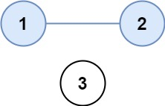

**Input:** isConnected = [[1,1,0],[1,1,0],[0,0,1]]

**Output:** 2

**Example 2:**

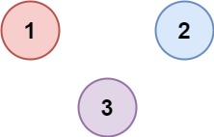

**Input:** isConnected = [[1,0,0],[0,1,0],[0,0,1]]

**Output:** 3

**Constraints:**

* 1 <= n <= 200
* n == isConnected.length
* n == isConnected[i].length
* isConnected[i][j] is 1 or 0.
* isConnected[i][i] == 1
* isConnected[i][j] == isConnected[j][i]